Renju lesson on November 8, 2001
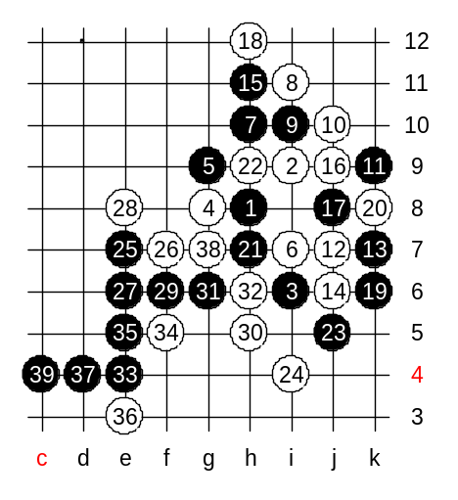
Hello everyone! Welcome to Online Renju Class. We will now begin. Today we will continue the study of i8 opening. We will continue with 4-g8. Now, look at 10-j10. It looks quite crazy, but many people have had success with it. I remember I prepared this 10th move about 8 years ago, and used it in the games against Reims and Veidemanis. Well, I was prepared against active moves, such as f10 and h12. But both Reims and Veidemanis simply played 11-k9, and crushed my position with strong positional style. It was about 7 years ago. After the 2nd loss, I gave up this 4th move completely. We can try some white blocks here, and then try to develop some black attack. It is just going according to my analysis. The only reason I remember is because I reviewed some basic ideas before last WC. To prepare the field for switching for positional play. The lower side action (j5) is the preparation of the attack. And the left side (e7) is the space development. The final part will be connecting them. Speaking of a space move, do you remember last week lesson. Now, thinking of it, could black play just e7 without going to j5 first? Do you remember I told you that the space move is good if it is connected to something, otherwise it might be too risky and opponent could get a counter-attack. How is e7 connected in our diagram now? By which path? Yes, both i5 and h5 are the connection bridges. Without having those connection bridges, black might be in trouble now. So, remember it is important to keep VCT threat while making a space move.
So, do you all understand the principle of positional attack – we first created the support (j5) and then development (j7) ?

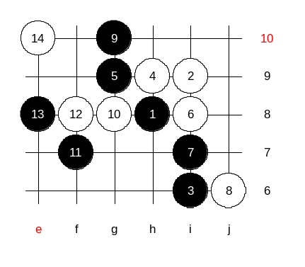
It is now time to study the last 4th move. Yes, h9. The 5th moves should not be too hard to guess. Where are they? We will check 5-g9 first, and leave 5-j9 for next week.
I have no idea how to block here. It looks really scary. We just try one random example of black attack.
After the 14th move black is very powerful. Let’s leave it as medium level homework.
The lesson is over now, thank you all for coming!
See you next week! :)

